Edge detection within a BMP image to isolate the license plate in an image

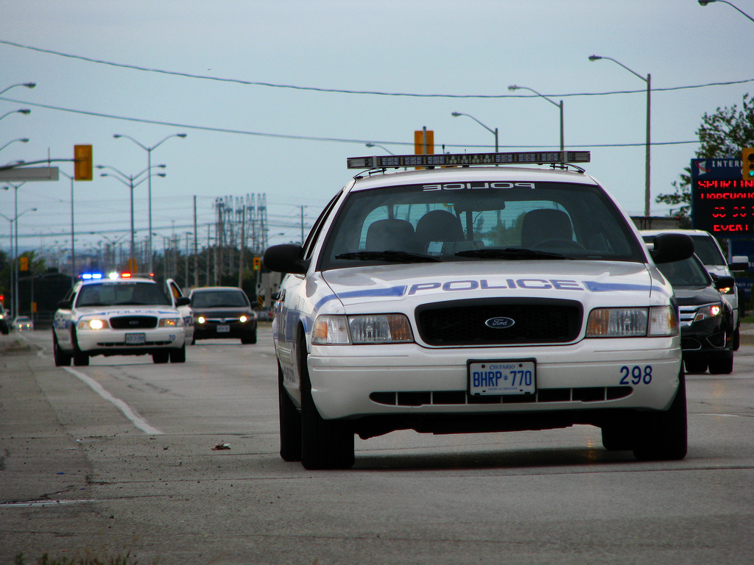



Edge detection within a BMP image to isolate the license plate in an image

Programming goals (40%)

* Identify edges at a pixel level (pixel neighbors)
* Identify a straight line of pixels across several rows or columns to make a segment
* Identify a rectangle of appropriate ratio as a license plate
* Modify the BMP image at that rectangle to color the license plate an attention-getting color,
  + Hexadecimal: Red=76, green=ff, blue=03. #76ff03
  + Decimal: Red=118, green=255, blue=3.
  + Reference: <http://htmlcolorcodes.com/color-chart/>

Writeup goals (60%)

* Two decent pages of writeup describing your approach and level of success
* Example: How did you identify a straight line of pixels across several rows or columns?
* Example: What guidelines, approximations, heuristics, “cheats” did you use?
* Example: Describe the issues and challenges in isolating the license plate in an image

Thurs., Apr. 7, 2016: NASA released close to 3 million images from the ASTER imaging instrument aboard the Terra Satellite that was launched in December 1999.

For the past 16 years, ASTER has been taking images of the Earth to create detailed maps of land surface temperatures, the amount of light the Earth reflects and its elevation.

ASTER provides data such as land surface climatology (land surface parameters, temperature, etc.), volcano monitoring and hydrology.

ASTER is used to create detailed maps of land surface temperature, reflectance and elevation. The instrument acquires images in visible and thermal infrared wavelengths, with spatial resolutions ranging from about 50 to 300 feet (15 to 90 meters).

ASTER data cover 99 percent of Earth's landmass and span from 83 degrees north latitude to 83 degrees south. A single downward-looking ASTER scene covers an area on the ground measuring about 37-by-37 miles (60-by-60-kilometers).

The broad spectral coverage and high spectral resolution of ASTER provide scientists in numerous disciplines with critical information for surface mapping and monitoring of dynamic conditions and changes over time. Example applications include:

* monitoring glacial advances and retreats,
* monitoring potentially active volcanoes,
* identifying crop stress,
* determining cloud morphology and physical properties,
* evaluating wetlands,
* monitoring thermal pollution,
* monitoring coral reef degradation,
* mapping surface temperatures of soils and geology, and
* measuring surface heat balance.

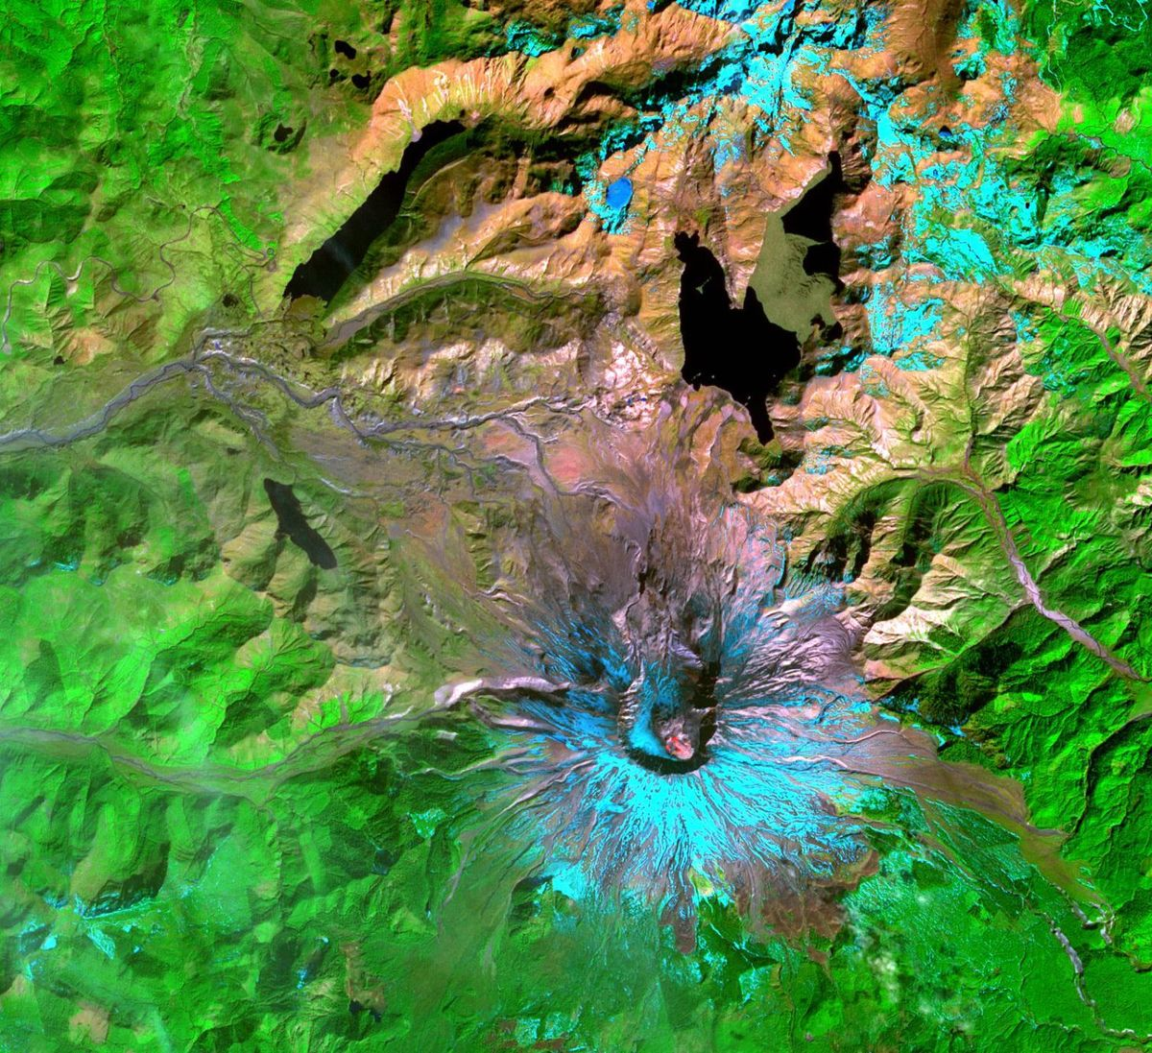

This ASTER image of Mount St. Helens was captured one week after the March 8 ash and steam eruption, the latest activity since the volcano's reawakening in September 2004. The new lava dome in the southeast part of the crater is clearly visible, highlighted by red areas where ASTER's infrared channels detected hot spots from incandescent lava. In this band combination, vegetation is green, snow is light blue and bare rocks are tan.